Hosting a Static Website in Azure Storage

1. Objective
The objective of this hands-on exercise is to host a static website using Microsoft Azure Storage Account and monitor its usage through metrics.

2. Goals of the Assignment
- Enable static website hosting
- Upload HTML files to the $web container
- Find and access the website URL
- Enable and monitor website metrics
- Delete the resources after completion

3. Part A – Enabling Static Website Hosting

Step 1: Sign in to Azure Portal
- Open https://portal.azure.com
- Sign in with Azure credentials

Step 2: Create Storage Account
- Click Create a Resource
- Select Storage Account
- Enter:
  - Resource Group: GL-STATICWEB-RG
  - Storage Account Name: glstatic
  - Region: Central India
  - Performance: Standard
  - Redundancy: LRS
- Click Review + Create
- Click Create
- Click Go to Resource
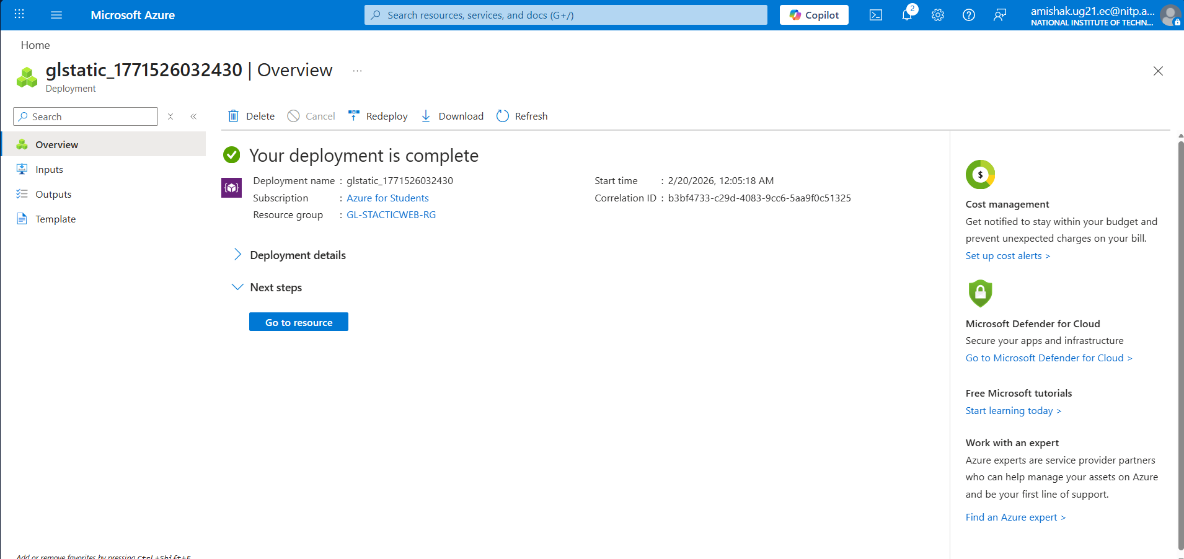
Storage Account Created Successfully

Step 3: Enable Static Website
- Go to Storage Account
- Click Static Website under Data Management
- Select Enabled
- Enter:
  - Index document name: index.html
  - Error document path: 404.html
- Click Save
After saving:
- $web container is automatically created
- Primary endpoint URL is generated
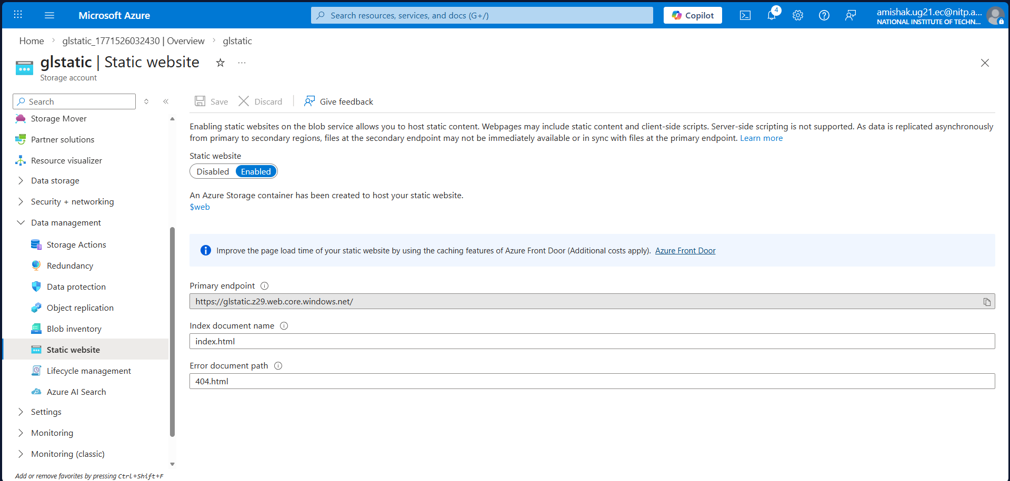
Static Website Primary Endpoint URL

4. Part B – Uploading Files to Container

Step 1: Open $web Container
- Click Containers
- Select $web
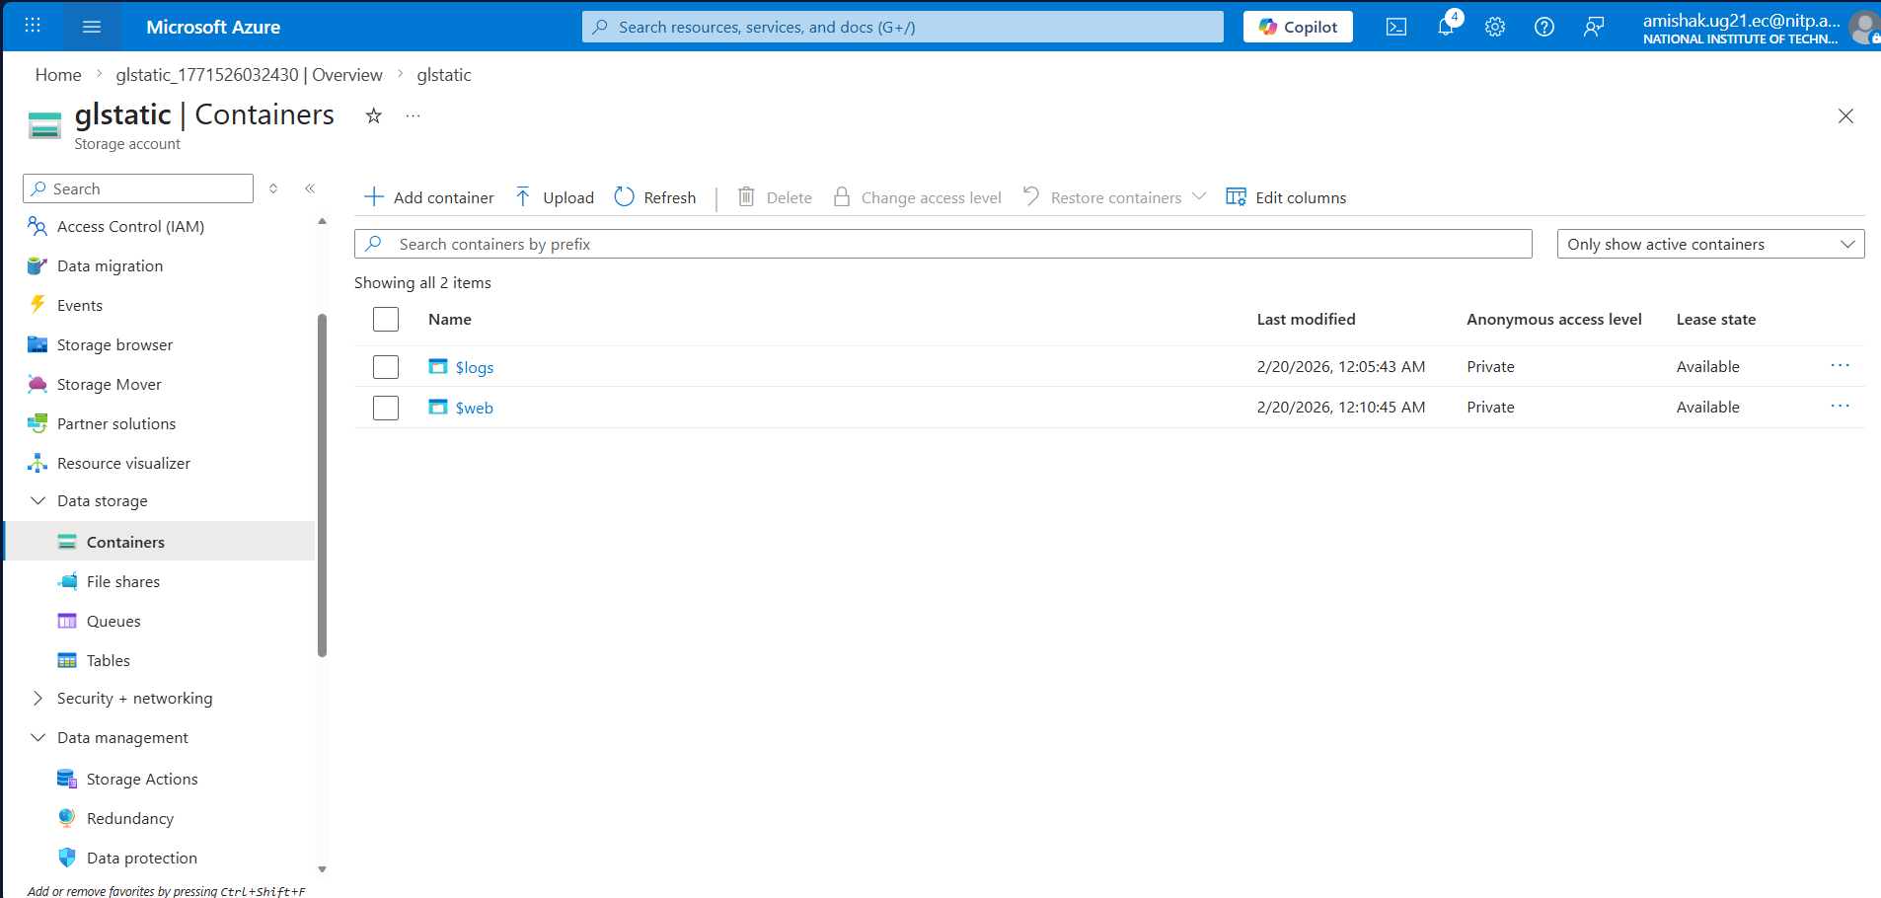
$web Container

Step 2: Upload index.html and 404.html
- Click Upload
- Select index.html
- Select 404.html
- Ensure Content-Type is set to text/html
- Click Upload
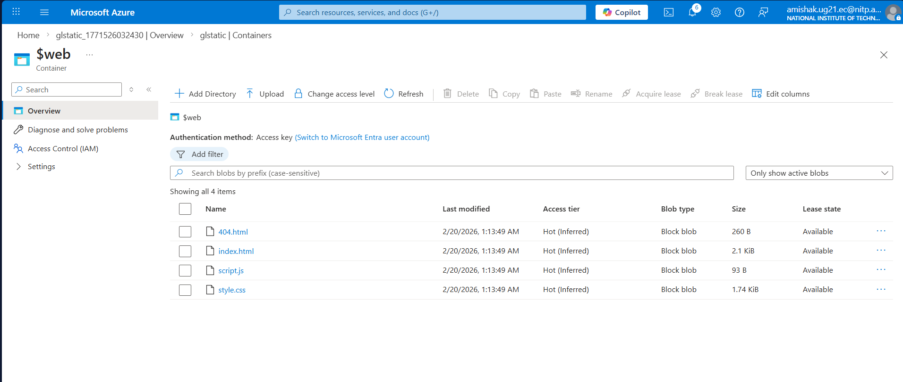Files Uploaded Successfully

5. Part C – Finding and Accessing Website URL

Step 1: Copy Website URL
- Go to Static Website
- Copy Primary endpoint

Step 2: Open in Browser
- Paste URL into browser
- Website loads successfully
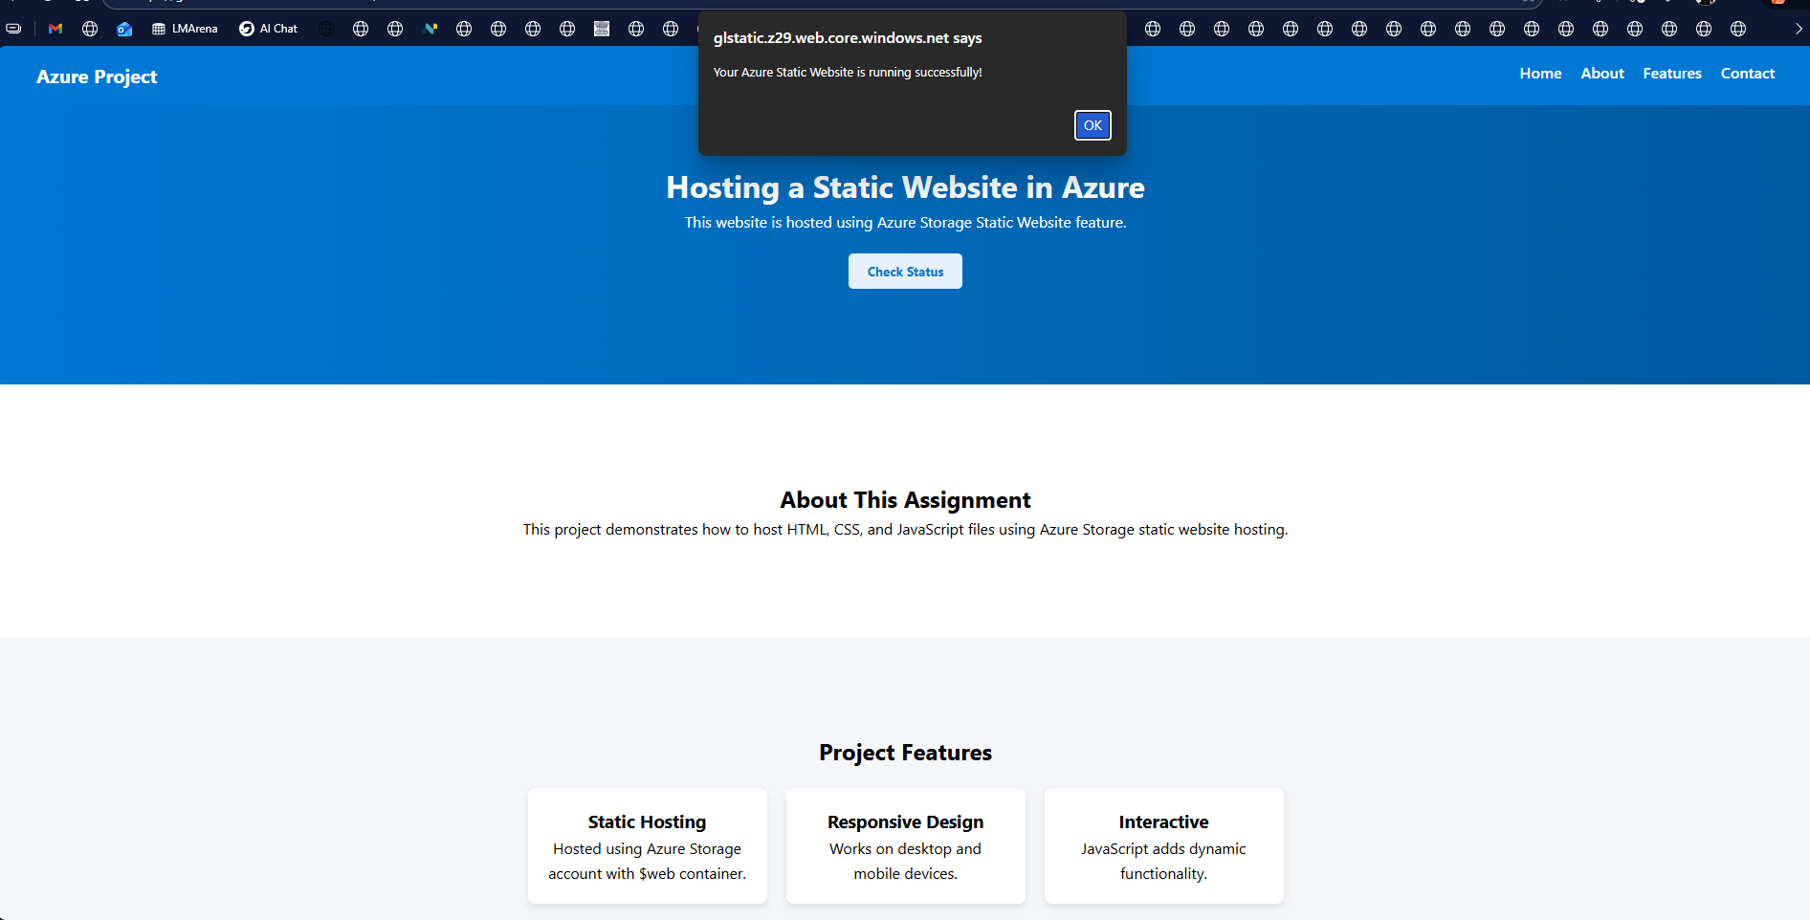Website Running in Browser

6. Part D – Enabling Metrics on Static Website Pages

Step 1: Open Metrics
- Go to Storage Account
- Click Metrics under Monitor section

Step 2: Configure Metrics
- Change Time range (Last 1 hour or more)
- Namespace → Blob
- Metric → Egress
- Aggregation → Sum
- Click Add Filter
  - Property → API Name
  - Select → GetWebContent
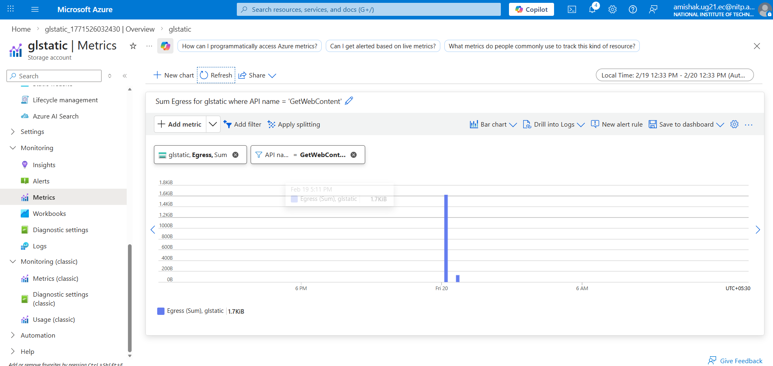
Metrics Showing GetWebContent
This shows website traffic and usage.

7. Part E – Deleting the Resources

Step 1: Delete Resource Group
- Go to Resource Groups
- Select your resource group
- Click Delete Resource Group
- Confirm deletion

8. Conclusion
In this assignment, we successfully:
- Created an Azure Storage Account
- Enabled Static Website Hosting
- Uploaded HTML files
- Accessed website via public URL
- Monitored website traffic using metrics
- Deleted all resources to avoid extra charges
This hands-on exercise demonstrates how static websites can be hosted and monitored using Azure cloud services.

